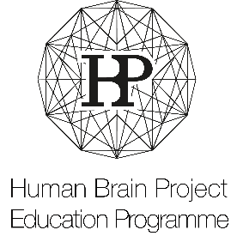

HBP Lab Visit announcement via the HBP Education website

Please fill out this form and send it to: education@humanbrainproject.eu
In case you offer different lab visits in different time periods, please fill out one form per offered lab visit.

Formularbeginn
- Details regarding the offered lab visit to be published on the HBP Education website
Name of hosting lab:
Number of lab visits offered by the respective lab / institute:
Duration of offered lab visit:
Period in which the lab visit is offered e.g. July – August 2017:
Description of lab visit:

Costs covered by the hosting lab e.g. research material:

Costs to be covered by the selected student e.g. travel costs, accommodation:

Scientific methods offered to the student:

Required language skills:

- Application details
Application deadline:
Application has to contain the following information e.g. name of current supervisor, list of publications etc.:

Application has to contain the following documents e.g. recommendation letter, copy of passport:

Short description of the application and selection process:

Application to be sent via email to the following address:

- Additional information / remarks
Additional information regarding the lab visit to be published on the HBP Education website:

Name and email address of contact person for internal communication with the Education Programme:

